Unit 7 Study Guide Name:

Stars, Fusion, Galaxies, The Universe, The Solar System, Planets, Kepler’s Laws, The Moon
Stars
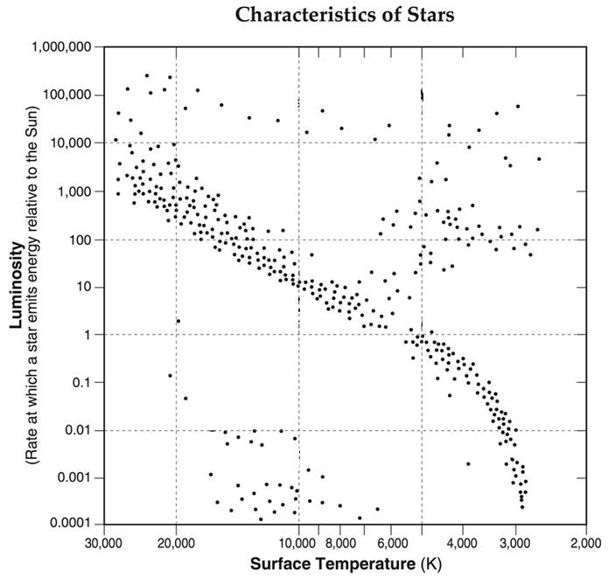
- What are the two forces acting on a star at all times, and what direction does each force point?

- The brightest star in the night sky is Sirius, in the Canus Major constellation, at 8.61 light years away. What does that 8.61 light years actually mean?

- On the HR diagram to the right, label giants, main sequence, supergiants, and white dwarfs. Also draw a STAR where the Sun is.
- What does LUMINOSITY mean?

- On the diagram to the right, where do I find the brightest, coolest stars?

- Where/how are stars born?

- Explain the 5 step lifecycle of OUR SUN, and how each step leads into the next.

- How old is our Sun?

- How much of the life of any given star is spent in the Main Sequence?

- For each of the following sized Stars, explain what will happen to the star, if it will supernova or not, and what the star will end up as?
  - 0x – 10x the size of our SUN

  - 10x – 30x the size of our SUN

  - 30x – 50x the size of our SUN

Fusion
- What is an isotope?

- Explain how ¹²₆C and ¹⁴₆C are different? Be specific in terms of the number of protons, neutrons, and electrons.

- In 7 words or less, explain what nuclear fusion is.

- Draw the 3 steps of the proton-proton chain reaction and EXPLAIN it in a sentence or two to the right of your picture.

- What is the largest element that is capable of being made during the fusion process inside a star?

- How many fusion stages inside a star are necessary to actually make this element? (Google image will help)

- How do larger elements than that element actually get made then?

- What is the largest element that can be created during a supernova?

- What is the largest element that our Sun will make during its lifetime? Why is that?

Galaxies
- List and draw the 3 major types of galaxies?

- Which of the above types of galaxies have new stars in them? Why do they have new stars in them?

- Which type of galaxy has a “normal” and a “barred” type?

- What is the name of our galaxy and what type is it?

- How old is our galaxy?

- How do galaxies get bigger?

The Universe
- What did the Universe start out as? List 3-4 properties of that thing we started off as?

- What is the equation for gravity?

- How do increase the gravitational pull between 2 objects?
- How long ago did the Big Bang happen, or how old is the universe?

- What is a theory in science?

- What are the 3 major pieces of evidence/data that support the theory of the Big Bang?

- What are the 2 major points of Hubble’s law?

- What are the 7 types of light from the Electromagnetic Spectrum, from longest wavelength to shortest wavelength?

- What does red-shifting mean?

- What do Cosmic Microwave Background Radiation show/tell us?

- List the order of when each of these happened, from first to closest to now?
  - Stars Form, Protons and electrons attach, Stable atoms began to form, Big Bang, Protons/Neutrons/Electrons form

The Solar System + The Planets
- What do stars form from and how do they form?

- What happens to the speed of the spin of an object when it is pulled in (think figure skater)?

- What is accretion?

- Name the 8 planets in order from closest to furthest from the Sun.

- What phrase can we use to remember this?

- What are the 2 major groups of planets? What caused these two groups to form differently?

- What are the 2 smallest planets in our Solar System?

- What are the 2 largest planets in our Solar System?

- What are 2+ trends you see within the major groups of planets?
- What are 2+ abnormalities you see when looking at data tables of each of the planets?

- Where are most of the moons in the Solar System found?

- In what 2 locations are most of the asteroids of our Solar System found?

Kepler’s Laws
- List, and briefly explain each of Kepler’s 3 laws of planetary motion.
  - 1st

  - 2nd

  - 3rd

- What does having an ellipse with an eccentricity of zero mean?
Planet | Eccentricity  ( 0 = circle )
Mercury | 0.205
Venus | 0.007
Earth | 0.017
Mars | 0.094
Jupiter | 0.049
Saturn | 0.057
Uranus | 0.046
Neptune | 0.011

- What does it mean as the eccentricity of an ellipse gets further away from zero?

- Which planet has the most rounded orbit?

- Which planet has the most compressed orbit?

The Moon
- How many moons are located inside of the Asteroid Belt?

- What is special about OUR moon compared to other moons in the solar system?

- Draw me the Sun, Moon, and Earth in a way that would cause the:
  - LARGEST TIDES SMALLER TIDES

- What does crescent mean? What does gibbous mean?

- What does waxing mean? What does waning mean?

