Unit 5 Study Guide Name:

Atmosphere and Ocean Circulation, Fronts, Weather Maps, Severe Weather, Hurricanes
Atmosphere Layers
- What are the 5 layers of Earth’s atmosphere? Start at the surface of the Earth and go on out. Also list how thick each layer is.

- Weather occurs in which layers?

- What is the difference between weather and climate?

- What layer is the ozone layer in?

- At what height does “Space Start?”

- At what height does the International Space Station Orbit?

- What happens to the spacing of molecules of air as you get higher and higher up?

- What are the 2 major gasses (and how much of each) that make up the atmosphere?

- What are the 6 major greenhouse gasses?

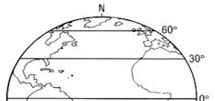
- What does the greenhouse effect do?

Atmosphere and Ocean Circulation
- Label the globe to the right with on each of the 3 regions with:
  - Names for each of the 3 weather cells
  - Where wind rises or sinks in global circulation
  - What the prevailing wind direction and name is for
- What causes air to move?

- What are the two solar things that cause uneven heating of air?

- Draw a picture of the Earth and the Sun, including the proper angles, showing the Northern Hemisphere during the winter.

- As air warms, what happens to the density, spacing of the molecules, and elevation (how far off the ground the air is)?

- Why does the Coriolis Effect exist?

- What affect does the Coriolis Effect have on fluids moving?
- What causes a sea breeze?

- Draw me an ocean breeze during a hot summer day. Draw the beach, ocean, and 2 arrows showing wind movement. Label which air is warmer and which is cooler.

- Cold salt water, Hot freshwater, Cold freshwater. Which would be on top, which would be in the middle, and which would be on bottom? Explain why.

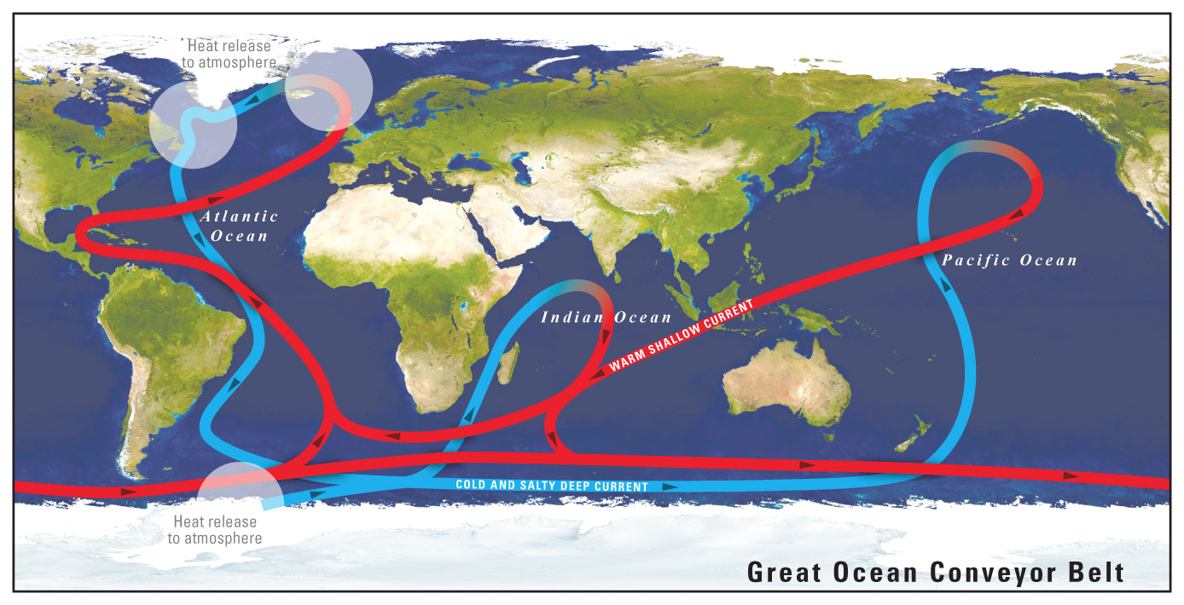
- What causes water to sink in the Northern Laditudes, thus causing the Ocean Conveyer Belt seen to the right?

- Using the image to the right. East vs West coast of the United States. Which one is getting warm ocean currents and which is getting cold ocean currents? Explain why this is true.

- How much of the Earth’s water was freshwater?

- How much of that freshwater was locked up in glaciers?

Fronts
- What is a weather front?

- (4 parts) List the 4 major weather fronts. Draw the symbol for each one (facing the top of the page). Then explain what weather is found at each front. Finally, make a quick sketch of each one showing arrows the movement of fronts and label each as warm or cold.

- What causes the movement of air?

- (5 parts) Make a table: What are the two major types of air masses, draw 4 arrows interacting with those two pressure systems, is it a cyclone or anticyclone, air rising or air sinking air, good weather or storms)

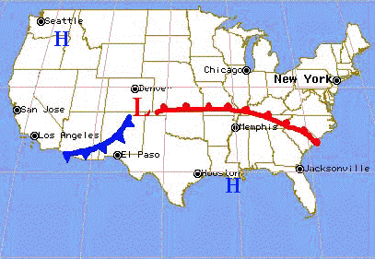
- (4 parts) Explain this image to the right. Explain the direction of the front movement, why it is circling around the front in that direction, explain why those fronts would be found in that location, and explain what type of air is found behind that front.

Weather Maps
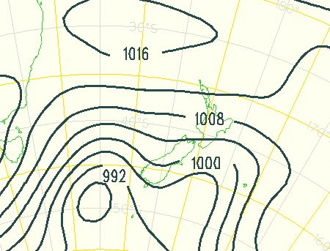

Temperature
Wind Speed and Direction (Towards)
Barometric Pressure
Dew Point
Cloud Cover
Use the image above for the following 3 questions:
- What is barometric pressure measured in and what is the barometric pressure at sea-level on average?

- On the image above with isobars, draw a solid square around where wind will be moving the fastest.

- On the image above with isobars, draw a solid triangle around where wind will be moving the slowest.
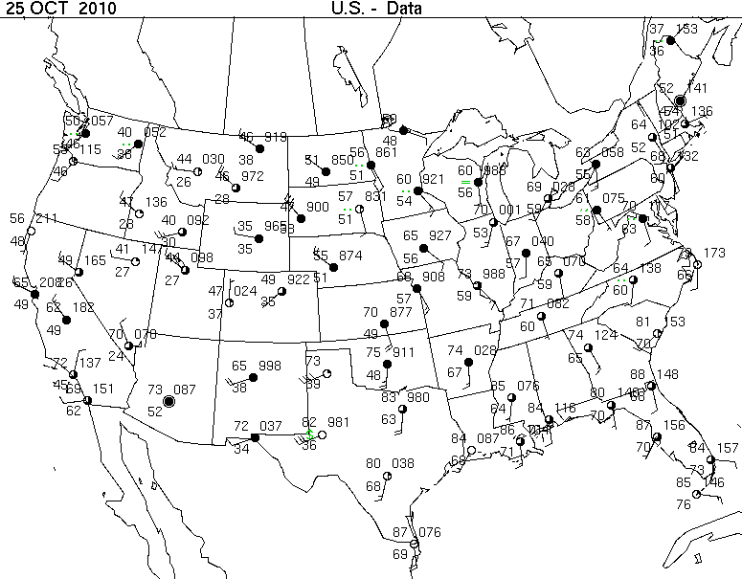
- What is the overall weather in Charleston, SC? (wind speed and direction, cloud cover, temperature, pressure)

- Where in the country is the wind moving the fastest? How fast is it moving, and WHY would it be moving fast?

- Where in the country is the lowest pressure, and what do you notice about the cloud cover around that area?

Severe Weather
- Explain what severe weather is.

- List 3+4 major forms of severe weather that are NOT thunderstorms.

- Explain the 3 basic steps of a thunderstorm forming.

- What fronts are most likely to have severe weather?

- Explain WHY these fronts have the most severe weather. Think about what is happening to the air masses.

- What is the scale for severity of tornadoes? Which one is the worst?

- Where and when are tornadoes most likely to occur?

- T Chart: List 2 ways that tornadoes and hurricanes are similar, and 2 ways that they are different.

Hurricanes
- What are the 3 things necessary for a hurricane to form?

- What are the 3 parts of a hurricane AND what characterizes each part?

- What is the life cycle (storms that occur) of a hurricane and what wind speeds characterize each storm level.

- How long can a hurricane (from start to finish) last and how long can it travel?

- What scale do we use to categorize hurricanes? Which wind speeds are necessary for the weakest and strongest hurricanes?

- Are hurricanes high pressure or low pressure? AND do they rotate clockwise or counterclockwise?

- How and why do we name hurricanes?

